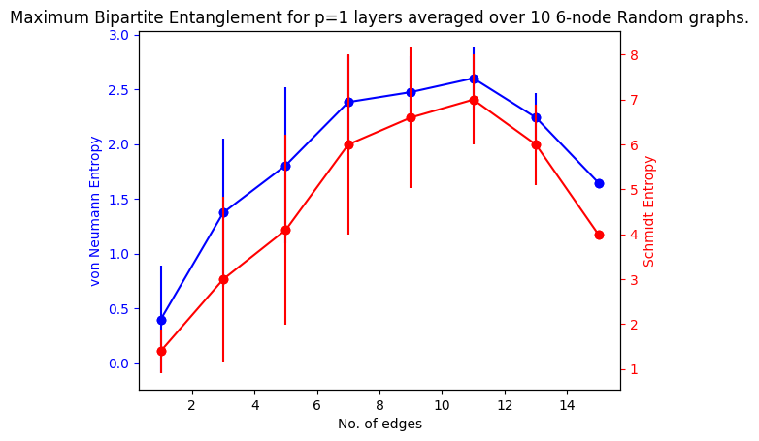

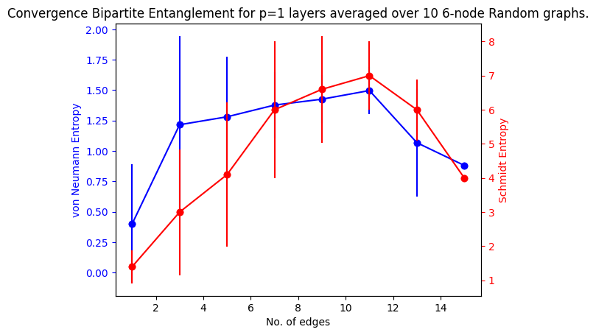

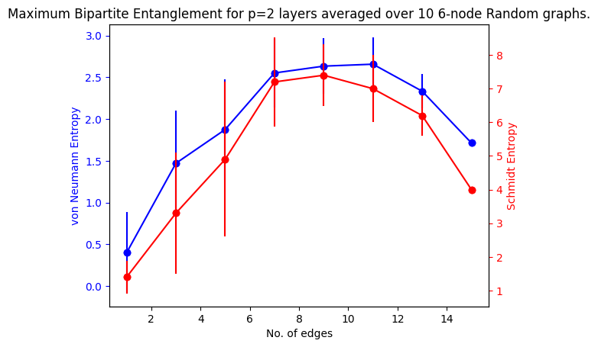

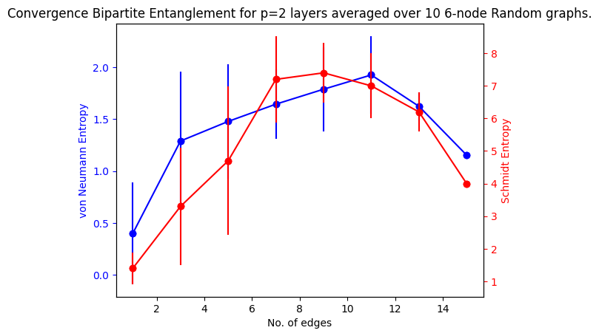

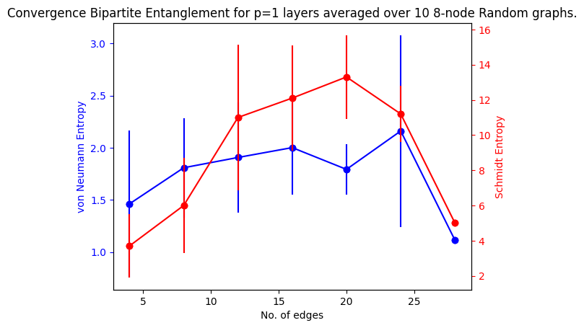

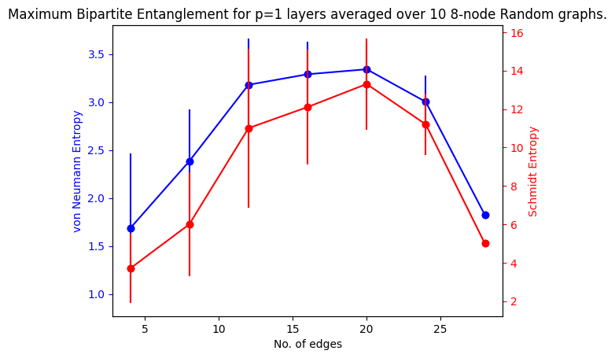



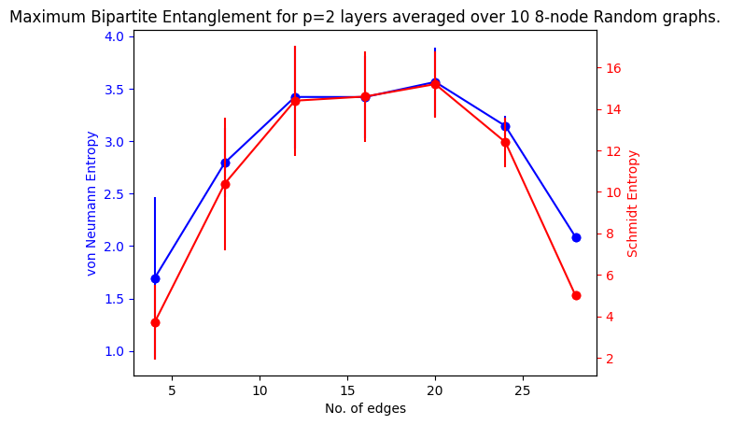

## 

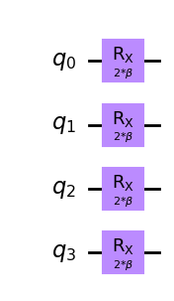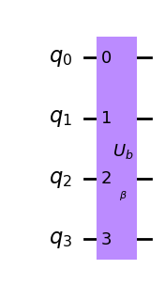

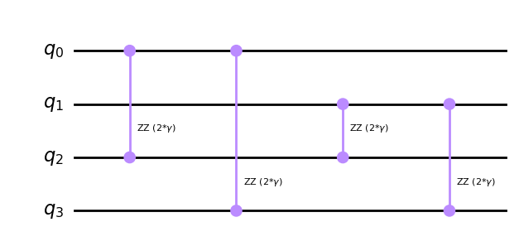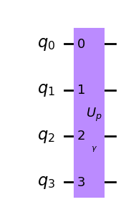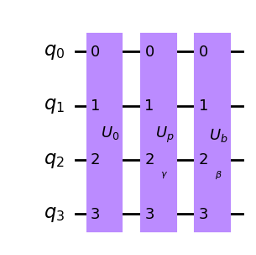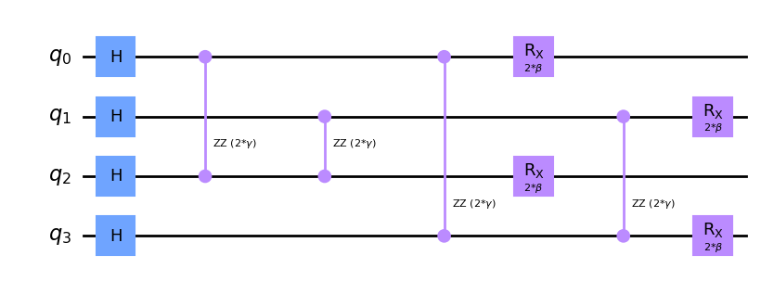

For a Complete Bipartite Graph with 4 nodes/qubits and a QAOA circuit with 1 layers:

The Schmidt number is : 3.

The final von Neumann entropy is : 1.2581133248644927.

It ranged from 0.5948824959160879 to 1.4063271952483627,with a mean of 1.2044479067236067and a standard deviation of 0.1784087419784114.

The initial parameters were : [1.0, 1.0].

The optimized parameters are : [1.97196795 1.16377673].

The total number of iterations required : 34.

The expectation value of the cut is : 3.046875.

The solutions are : 0011, 1100 with a MaxCut = 4.

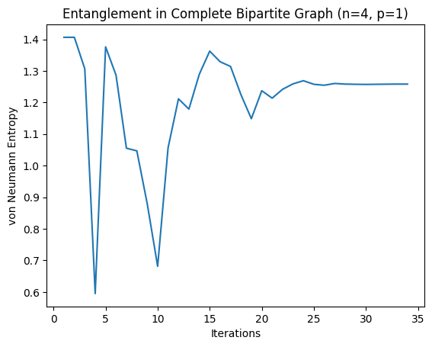

For a Complete Bipartite Graph with 4 nodes/qubits and a QAOA circuit with 2 layers:

The Schmidt number is : 3.

The final von Neumann entropy is : 1.0107202633254544.

It ranged from 0.12243316333072546 to 1.5181196894663964,with a mean of 1.101557843017292and a standard deviation of 0.2277108537668061.

The initial parameters were : [1.0, 1.0, 1.0, 1.0].

The optimized parameters are : [2.11841312 2.04440492 1.12132851 1.00830629].

The total number of iterations required : 41.

The expectation value of the cut is : 3.994140625.

The solutions are : 0011, 1100 with a MaxCut = 4.

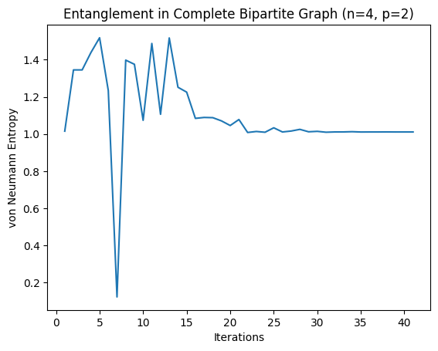

For a Complete Bipartite Graph with 4 nodes/qubits and a QAOA circuit with 8 layers:

The Schmidt number is : 3.

The final von Neumann entropy is : 1.0002202000411358.

It ranged from 0.4482969928935446 to 1.5167810783433064,with a mean of 1.0598431999043325and a standard deviation of 0.15535157471717517.

The initial parameters were : [1.0, 1.0, 1.0, 1.0, 1.0, 1.0, 1.0, 1.0, 1.0, 1.0, 1.0, 1.0, 1.0, 1.0, 1.0, 1.0].

The optimized parameters are : [0.99507308 1.6743001 0.9379226 1.01007157 1.01938732 1.02996145

1.26737769 0.97211943 1.00009311 0.98401781 0.98915784 0.9490906

0.87771188 0.99156498 0.99866022 0.9862206 ].

The total number of iterations required : 138.

The expectation value of the cut is : 4.0.

The solutions are : 0011, 1100 with a MaxCut = 4.

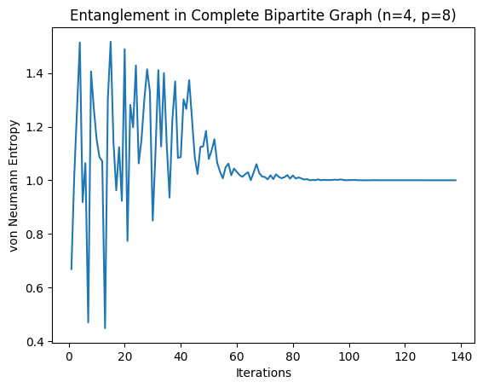

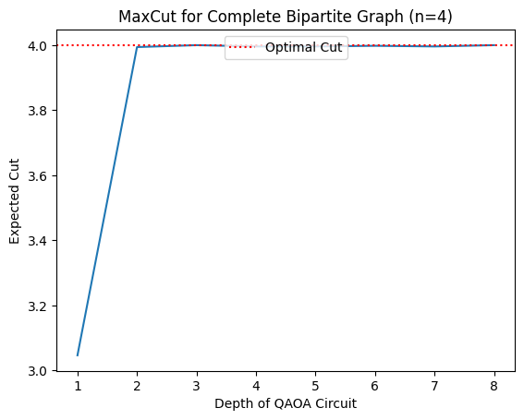

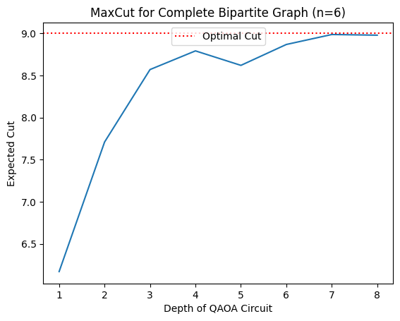

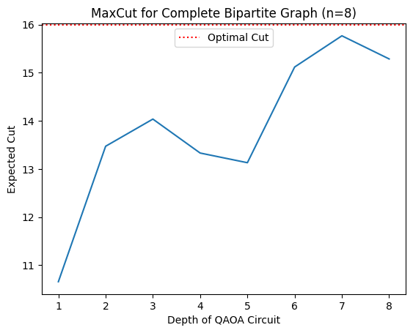

For a Complete Graph with 4 nodes/qubits and a QAOA circuit with 1 layers:

The Schmidt number is : 3.

The final von Neumann entropy is : 0.8114858475726201.

It ranged from 0.02238273411790983 to 1.4063271952483625,with a mean of 0.812286872306336and a standard deviation of 0.31631734030789577.

The initial parameters were : [1.0, 1.0].

The optimized parameters are : [ 0.27386881 -0.25638493].

The total number of iterations required : 32.

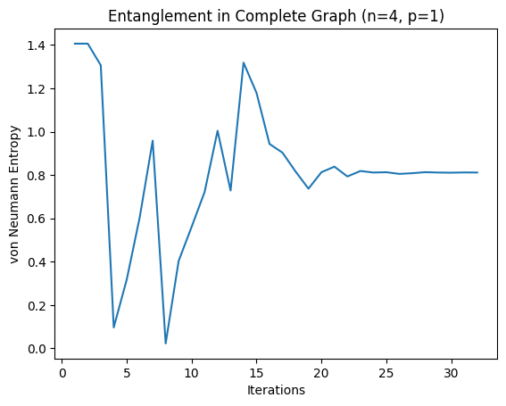

For a Complete Graph with 4 nodes/qubits and a QAOA circuit with 2 layers:

The Schmidt number is : 3.

The final von Neumann entropy is : 1.2410884586647335.

It ranged from 0.648337935049995 to 1.5018040762516167,with a mean of 1.1777525209326016and a standard deviation of 0.1541726274397403.

The initial parameters were : [1.0, 1.0, 1.0, 1.0].

The optimized parameters are : [2.09149094 0.79891856 1.11266271 0.89310857].

The total number of iterations required : 50.

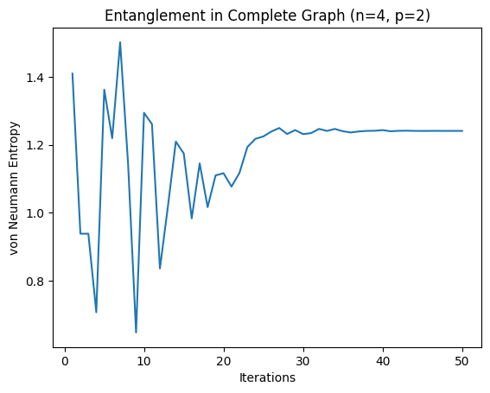

For a Complete Graph with 4 nodes/qubits and a QAOA circuit with 8 layers:

The Schmidt number is : 3.

The final von Neumann entropy is : 1.2511771667768488.

It ranged from 0.5967486509623638 to 1.5567038647714941,with a mean of 1.2032746866307507and a standard deviation of 0.1291506996066402.

The initial parameters were : [1.0, 1.0, 1.0, 1.0, 1.0, 1.0, 1.0, 1.0, 1.0, 1.0, 1.0, 1.0, 1.0, 1.0, 1.0, 1.0].

The optimized parameters are : [1.88697336 1.00993252 1.31460581 1.14472777 0.80970761 0.94071308

 0.91425457 0.92025624 0.95889828 1.02175675 1.91158378 0.98774881

 0.97519891 1.07293637 1.04254776 0.97899366].

The total number of iterations required : 169.

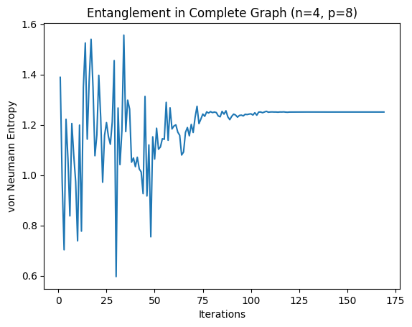

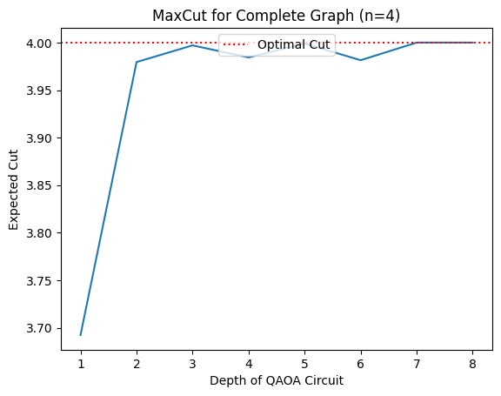

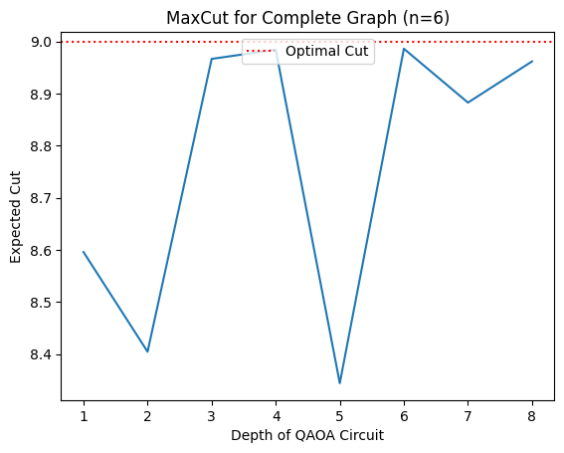

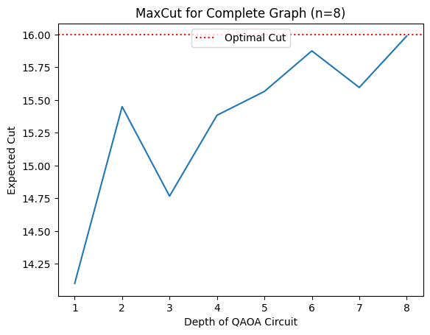

1 sample

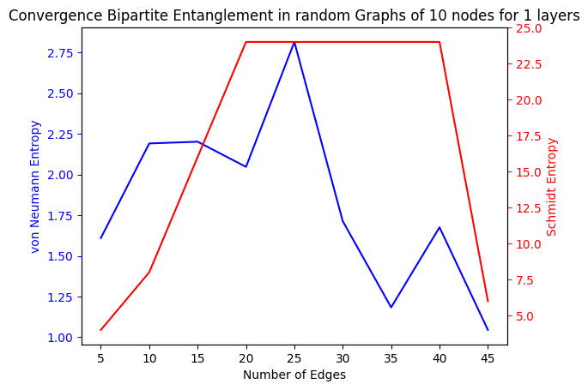

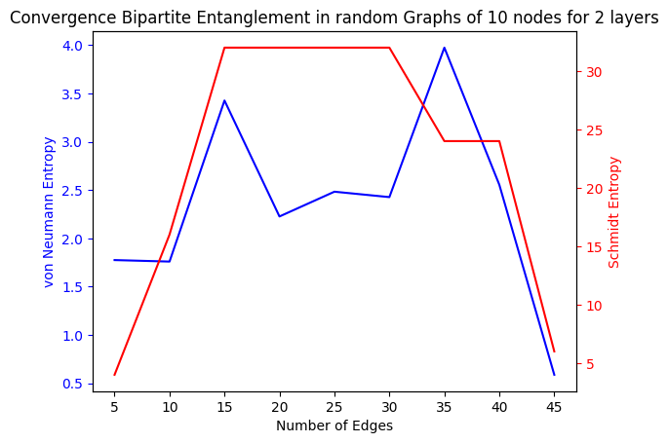

100 loops

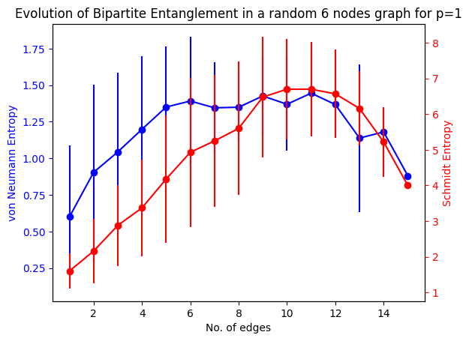

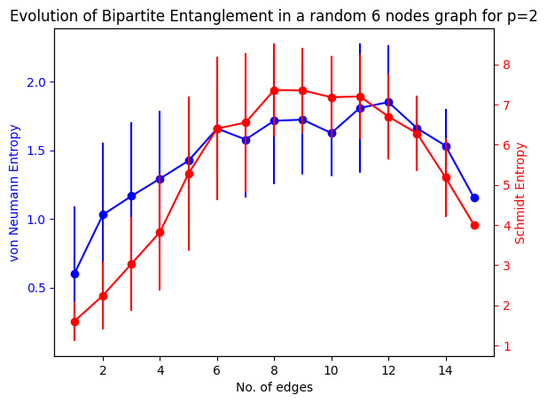

8 nodes, 4->28 in steps of 4, 10 loops, 1024 shots

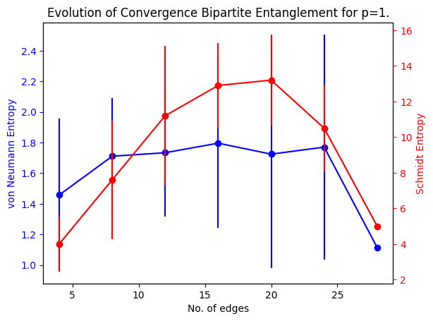

10 nodes, was supposed to be 3->45 edges, steps of 3, but stopped at 27 edges, 10 loops, 1024 shots

